**Mid Project: Solitaire Game**

**Session 2023-2027**

**Submitted by:**

Muhammad Hassaan Shahid 2023-CS-79

**Supervised by:**

Sir. Nazeef-ul-Haq

**Course:**

Data Structures and Algorithms

**Department of Computer Science**

**University of Engineering and Technology,**

**Lahore, Pakistan**

**Project Description:**

I have developed this solitaire game in C# console in which I used linked list, nodes, lists, arrays, stacks, queues. By stacks I developed the tableau piles and foundation piles and using queue I developed stock piles and

**Introduction**

This Solitaire game is a text-based implementation developed in C# for the console. It follows the classic rules of Solitaire, where the player’s goal is to move all cards into the foundation piles sorted by suit from Ace to King. The game includes functionalities to start, play, undo, redo moves, and quit, all within a console environment.

**Game Flow Overview**

The game flow consists of three main stages:

a. Starting the Game

When the game is launched, the player is greeted with a start screen that prompts them to either:

- Start the Game - Initiates the game setup and deals the cards.

- Exit - Closes the application.

b. Playing the Game

After starting the game, the console displays the main gameplay interface with:

- The Stockpile (deck of cards yet to be drawn)

- WastePile (cards drawn from the stockpile but not yet placed in foundation or tableau)

- Foundations (where sorted cards are placed in ascending order from Ace to King)

- Tableau Stacks (seven columns where cards are arranged in descending order and alternate colors)

The player can make various moves as outlined in the menu:

1. Move card from stockpile to stack

2. Move card from stockpile to foundation

3. Move card from stack to foundation

4. Move card from stack to stack

5. Draw the next card in stockpile

6. Undo the last move

7. Redo the last undone move

8. Quit the game

c. Ending the Game

Upon completing the game, where all cards are successfully moved to the foundation, the console displays a congratulatory message. The player can then choose to:

- Play again

- Exit the game

3. User Interface Elements

The game is presented in ASCII art for a simple and engaging console experience:

- Tableau Stacks are numbered from (1) to (7).

- Stockpile and WastePile positions are indicated, showing the top card available.

- Foundation piles are labeled to indicate where suits are sorted.

- Instructions for making moves and entering commands are presented in a numbered list for clarity.

4. Game Mechanics

The game mechanics emulate traditional Solitaire rules:

- Tableau Stacks: Cards can be moved between stacks in descending order with alternating colors.

- Stockpile and WastePile: Cards are drawn one at a time from the stockpile to the waste pile.

- Foundations: Sorted by suit, these are built from Ace to King.

Moves such as "Undo" and "Redo" enable players to correct mistakes, providing a user-friendly experience.

5. Functionalities

1. Start Game: Initializes the game, shuffles the deck, and deals cards to the tableau.

2. Move Cards: Allows movement from the stockpile to tableau or foundation, and between tableau stacks.

3. Undo and Redo Moves: Supports reverting to previous states or reapplying undone moves.

4. Quit: Exits the game from any state.

5. Restart: After winning or quitting, allows a fresh start.

# Moving Cards between Stack Piles:

1. Cards in Stack piles must be placed in descending order (King to Ace).  
2. Cards must alternate colors (red for hearts/diamonds, black for clubs/spades).  
3. Only a King can be moved to or placed in an empty tableau space.  
4. You can select a face-up card in a tableau pile and move it to another tableau pile if it follows the descending order and alternating color rules.

# Moving Cards to Foundation Piles:

1. Foundation piles are built up in ascending order by suit (hearts, diamonds, clubs, and spades).  
2. Start with an Ace in each foundation pile, and then build up by rank in ascending order (Ace, 2, 3, King).  
3. You can move a card from the tableau piles or the stockpile to the foundation if it is the next card in the sequence for that foundation pile.

# Drawing Cards from the Stock Pile:

Draw one card at a time from the stockpile and place it in the waste pile. If the stockpile becomes empty, you can reshuffle the waste pile to create a new stockpile and continue drawing.

# Valid Moves:

Moves are allowed between tableau piles if they follow the descending order and alternating color rules. Cards can also be moved from Stack piles or stockpile to the foundation if they follow the correct sequence (Ace to King) and suit.

# Wireframes:

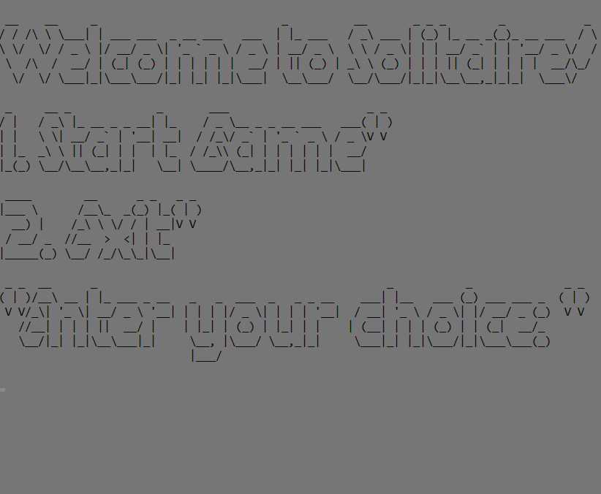

**Figure 1-Start-Screen**

*1. Starting Screen*

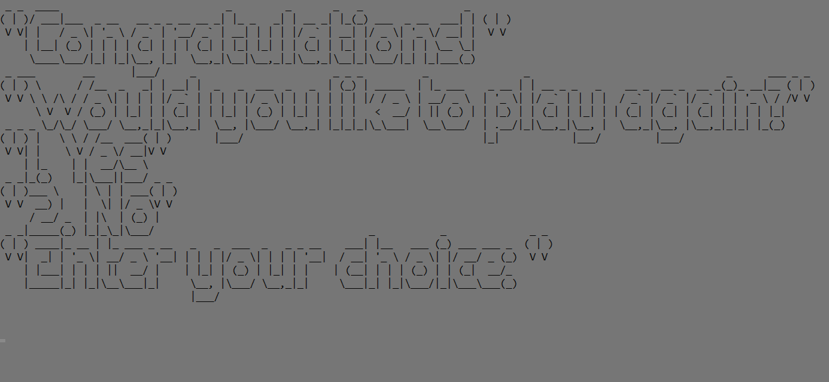

*2. Wining Screen*

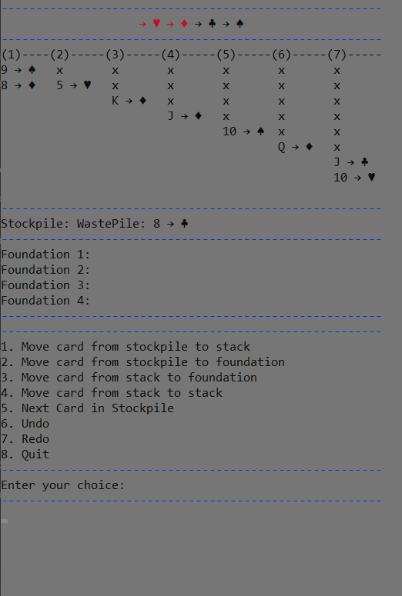

*3. Game Screen*